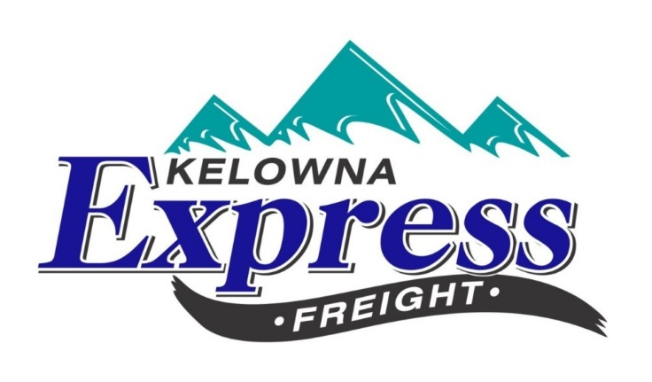
New Customer Account Form
Customer Information
Main Address Billing Address if different
Company Name : ______________________________ Company Name: _________________________
Address : _____________________________________ Address: _______________________________
_____________________________________________ _______________________________________
City/Province: _________________________________ City/Province: ___________________________
Postal-code: __________________________________ Postal-code: ____________________________
Telephone: ___________________________________ Telephone: _____________________________
Fax: _________________________________________ Fax: ___________________________________
Account Contact(s): ____________________________________________________________________
Position Held: ________________________________
Email Address(s): _____________________________
Website: ____________________________________
Payment Preference: (circle one) Cheque EFT

We currently bill on a bi-monthly basis (15th and last day of each month) with standard Net 15 day terms. We currently accept payments by cheque, credit card and EFT. Please forward a form to set up EFT if that’s how your company would like to pay invoices. There is a 2% late charge for delinquent accounts. Invoices are emailed through kelownaexpress@intuit.com. Please complete this form and email back to heather@kelownaexpress.com or kelownaexpressfreight@hotmail.com

